40.51: a) 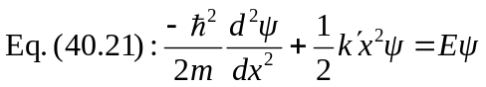
Now, 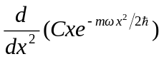
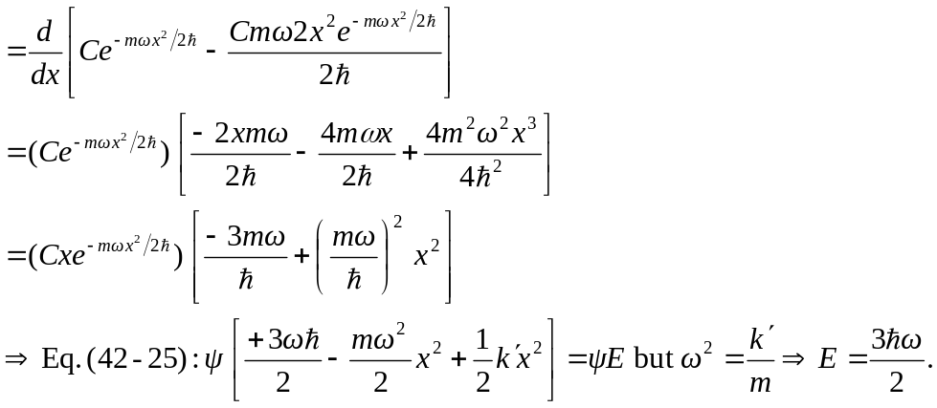

b) Similar to the second graph in Fig. 40.18.

